Customer Journey Map
Ideation Phase | Network Requester experience
Phase: 1. Ideation Phase
Project | Automated Network Request Management | Date | 20 October 2026
Owner / demonstrator | PILLEM RAHUL | SkillWallet ID | SWUID2026232277
Platform | ServiceNow PDI | Repository | github.com/rahulp06/Automated_Network_Request_Management_in_ServiceNow

Purpose and method note
This map describes a plausible requester's journey through the demonstrated catalog workflow. It is grounded in observed form fields, mandatory-field validation, REQ/RITM linkage, approval/rejection testing and outbound notifications. The questions and pain points are design hypotheses, not survey or interview results.

Journey visual
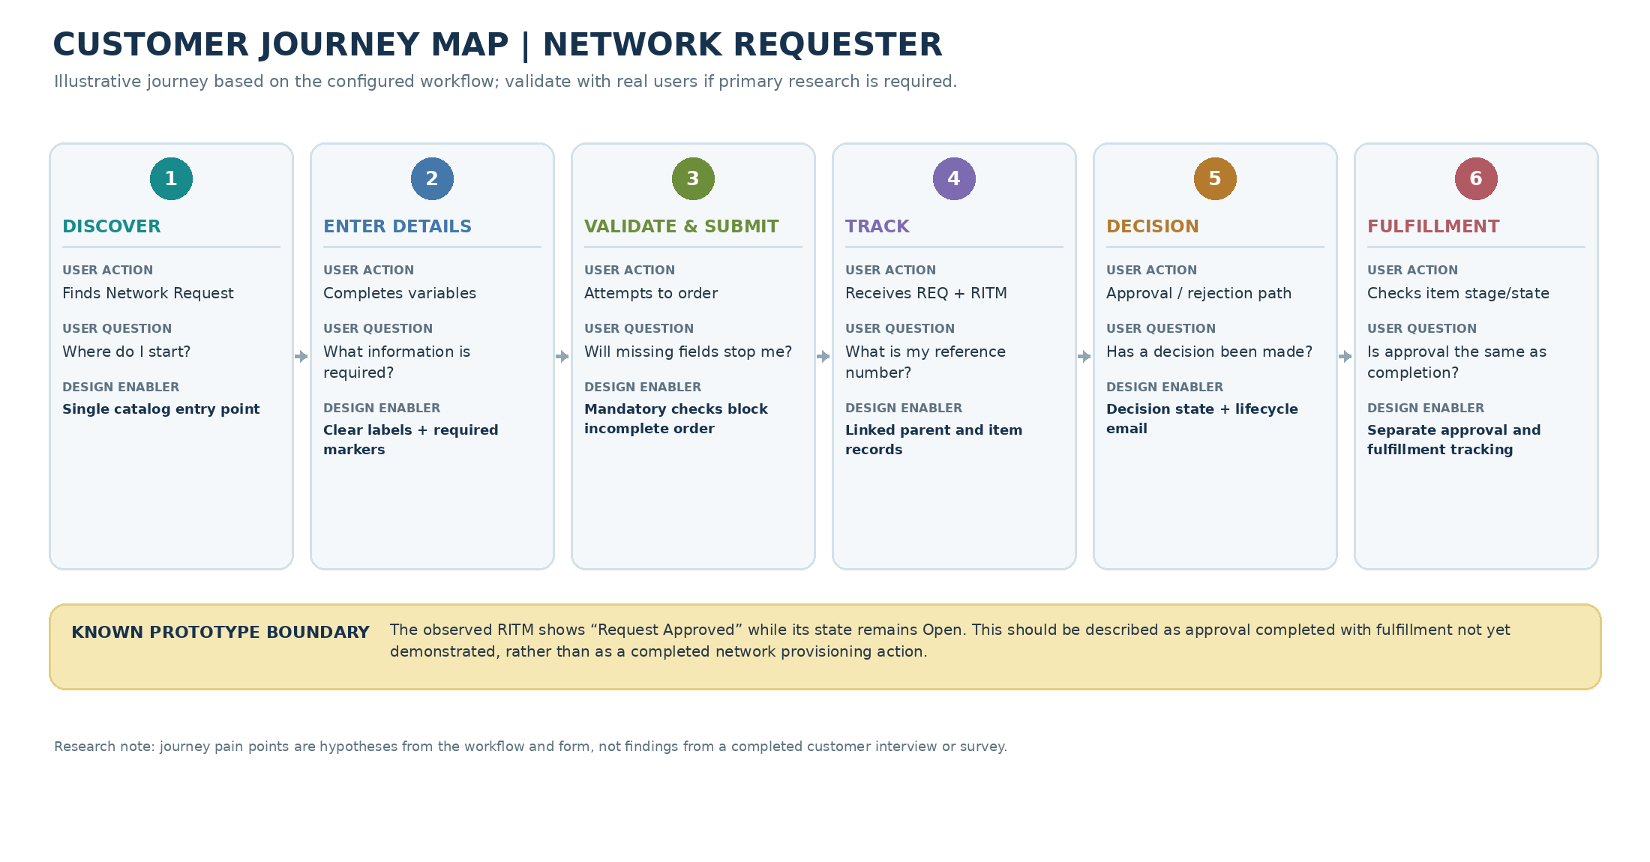
Figure 1. Customer journey map for the ServiceNow Network Request prototype.

Stage-by-stage interpretation
Stage | User goal | Potential friction | Design response | Observed evidence
Discover | Find the Service Catalog item. | User does not know where to begin. | Expose one clearly named Network Request catalog entry. | Catalog item opened successfully.
Enter details | Provide requester information and connection type. | User may miss a required field. | Use clear labels and required markers. | Required markers visible in the form.
Validate and submit | Submit a complete order. | Missing data could create back-and-forth. | Prevent incomplete order submission. | Order Now was blocked when required values were blank.
Track | Use REQ and RITM references. | User may not know what identifier to reference. | Maintain parent Request and linked Requested Item. | REQ0010004 linked to RITM0010005.
Decision and notify | Understand approval or rejection. | Unclear decision status may cause follow-up. | Show configured decision outcome and send lifecycle messages. | Both outcomes tester-confirmed; outbound email received.
Fulfillment | Check item state after approval. | Approval may be mistaken for completed service. | Distinguish approval from fulfillment stage/state. | RITM stage Request Approved; state Open; completion not demonstrated.

Implications and next steps
- Keep the mandatory-variable validation in place and use the catalog form as the single intake point.
- Show the request identifier and its related requested item in the demo so the parent/child relationship is easy to follow.
- Do not describe approval as completed network provisioning; the observed RITM remained Open after approval.
- If the assessment rubric expects actual customer research, conduct brief requester/approver interviews and revise the hypothesized pain points using their feedback.

